NSSA-220 Project 1: Application Performance Monitoring

Key Zollner, Brandon Pascucci, Aiden Ashworth

Introduction

The goal of this project was to learn how to work as a team to create an Application Performance Monitoring (APM) tool using Bash in a shared Rocky Linux Deployment. A script was designed to run the 6 provided APMs and collect data about the CPU, memory usage, network bandwidth, and hard disk activity in five second intervals. The collected data was saved to multiple csv files and transferred to a pre-provided Excel sheet that would graph the information. Through analyzing these graphs, we would be able to better learn how APMs and apps use system resources and notice when potential performance issues can arise.

Process Level Metrics

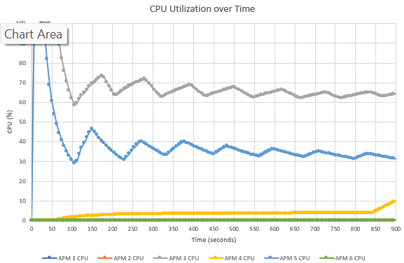
The plot shows that the CPU utilization for all six APMs are very different, with APM 3 and APM 5 consistently using the most CPU, both peaking at around 100% and then oscillating about 65% and 32% respectively with decreasing amplitudes. There other 4 APMS used very little to no CPU, apart from a spike from APM 4 at the end.

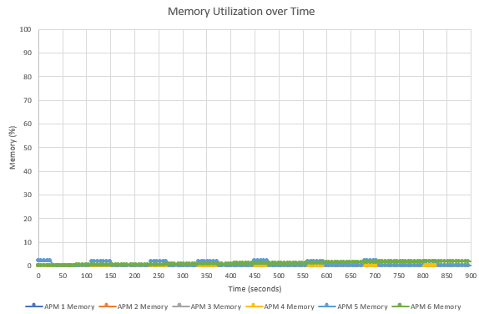
Memory utilization is never that high for any of the APMs. They are all consistently under 5% with a similar oscillating pattern to the CPU utilization graph, just with much smaller amplitudes. There does not seem to be any memory leak.

Potential things to write about: Which processes used the most CPU/memory? Which processes used the least CPU/memory? Did any processes have any interesting patterns in their CPU and/or memory utilization? Could you see a memory leak (memory use that only increased over time) in any of the processes?

System Level Metrics

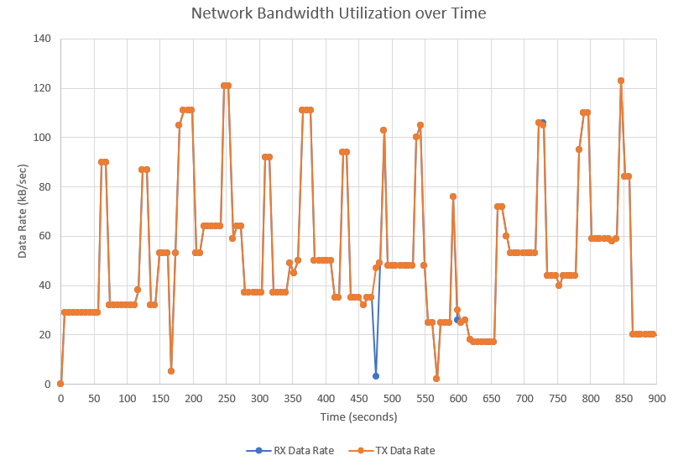
The network bandwidth plot above, the transmit data rates where either the same or higher than received data rates. There seems to be no pattern in the shape other than that it varied often with large spikes.

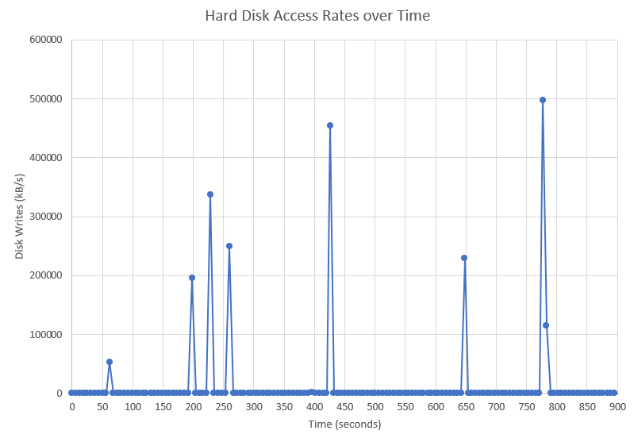
The hard disk access rates were mostly very low or zero, with a few spikes in disk writes. The largest of these spikes were between 450,000 kB/s and 500,000 kB/s.
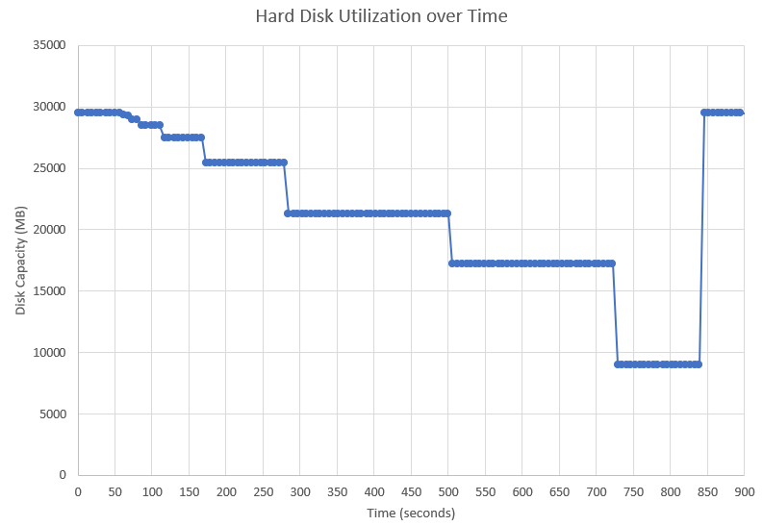
The available disk capacity was slowly decreasing in jumps for a majority of the time. Close to the end of the test shows a return to almost 30,000 MB capacity.

Summary and Lessons Learned
Overall, the VM we used seemed to have enough resources for all six applications, despite some worrying CPU usage at the beginning. Network activity remained consistent and not totally saturated, and memory usage remained surprisingly low. CPU was the most heavily used resource, and was fully used by both APM 3 and APM 5 near the beginning, but as time went on, the usage became more optimized, and disk activity showed occasional large spikes but nothing that would cause a meaningful performance issue. Throughout this project, our group members learned how to divide and conquer work, review each other’s work for issues, and analyze system and performance level data through graphs and data collection, all of which can be used beyond the scope of this course and the creation of a Bash script.

